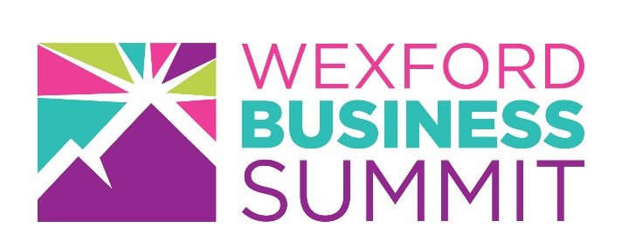

Get More for Your Business
Why attend?

The 2018 Wexford Business Summit is where businesses like yours find the next gear. It's free to attend and offers a wealth of opportunity, advice and information crucial for on-going business within a growing economy. The event welcomes businesses from a broad section of industries and is committed in providing you with everything needed to improve, evolve and expand your business.
Here are a few of the benefits of attending this year’s Summit:

- One to One meetings with procurement managers to secure new contracts.

- Benefit from attending the insightful amazing speakers- learn from the best!

- Meet with staff of local and national government agencies and find out what supports are available for your business.

- Network with local and national business leaders that can help you develop your business. Meet new suppliers and potential customers.

- Have an opportunity to have your business challenges solved by our range of industry experts. Pitch to the Angels!

- Benefit from attending insightful seminars and workshops which will provide you with new ideas for your business.

- Win a cash prize of €500 and get an opportunity to meet with Angel Investors and find out what they look for in a business.

- Meet with staff of local and national government agencies and find out what supports are available for your business.

Who should attend?
Business owners, Senior Managers, Regional Directors, Aspiring Entrepreneurs, Bankers, Business Advisors, Buyers, Sales representatives, Trade Associations, Educational Bodies, Government Bodies, Media & Press.

