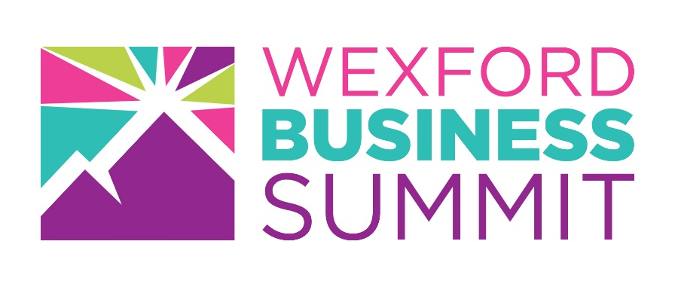
Get More for Your Business

Exhibitor Benefits- Wexford Business Summit 2018
Being at the 2018 Wexford Business Summit gives you connections to up to 1,000 B2B visitors on a face to face basis.
As an exhibitor you get 1st call to meet procurement teams in the Meet the Buyers event during the Wexford Business Summit. Get new contract & contacts at #WexBizSummit.
Why Exhibit at The 2018 Wexford Business Summit?
- Identify new opportunities by attending our programme of inspiring speakers and Angel’s Den & Meet the Buyers Events.
- Meet with new potential customers and suppliers.
- Reach your target market and get more qualified leads.
- Get direct face to face contact with decision makers.
- Increase the profile of your business in County Wexford.
- Increase your database of contacts in the world of business.
- Strengthen your existing client relationships.
- As all exhibitors are B2B service/product providers, create strategic alliances.
- Reach a large number of people in just one day, great investment of your time
For further information visit www.wexfordbusinesssummit.ie

